Notes 9-1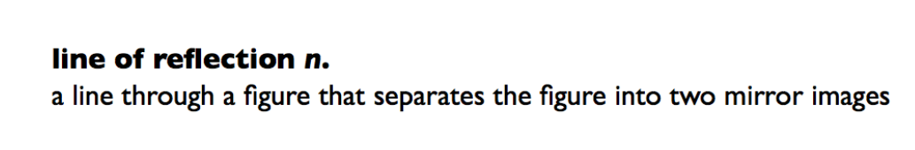

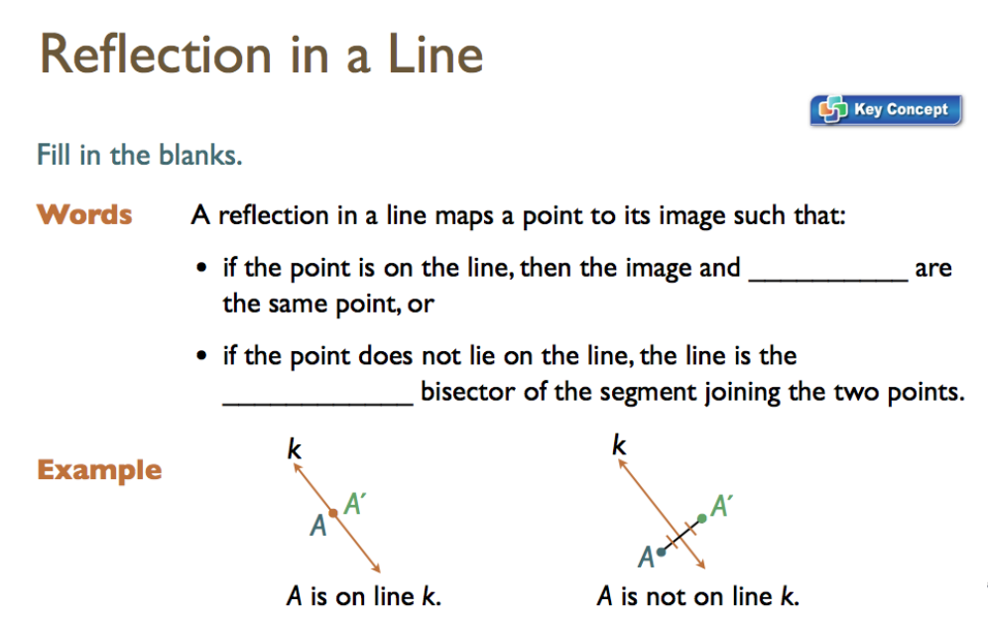

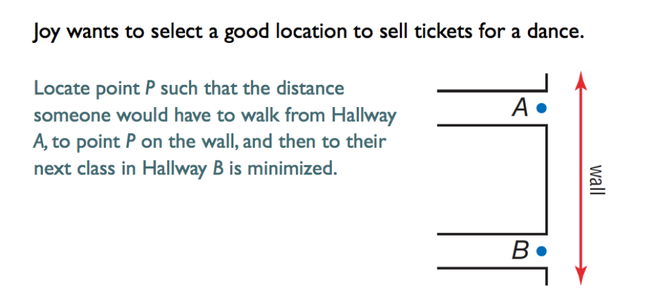
1st) Construct a perpendicular bisector halfway between points A and B
Draw a line between A and B
Find the midpoint between A and B and name it C
Construct the perpendicular bisector of that point
Place compass at midpoint
Draw arcs to the left and right of midpoint that intersect the line drawn (label points of intersection D and E)
Place Compass at D and draw an arc to the left of AB that is longer than AC.
Using the same compass setting draw an arc from E that intersects the first arc (Label intersection pt Q)
Use a straight edge to connect Pt Q and Pt C

2nd) The point where it hits the wall is the equidistant point from both hallways.

