Notes 6-6

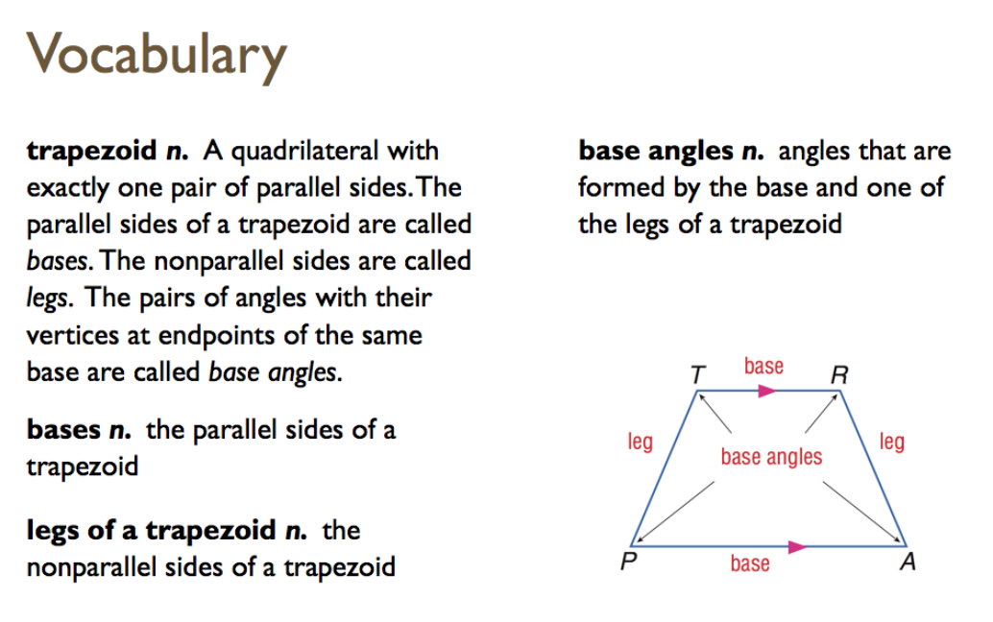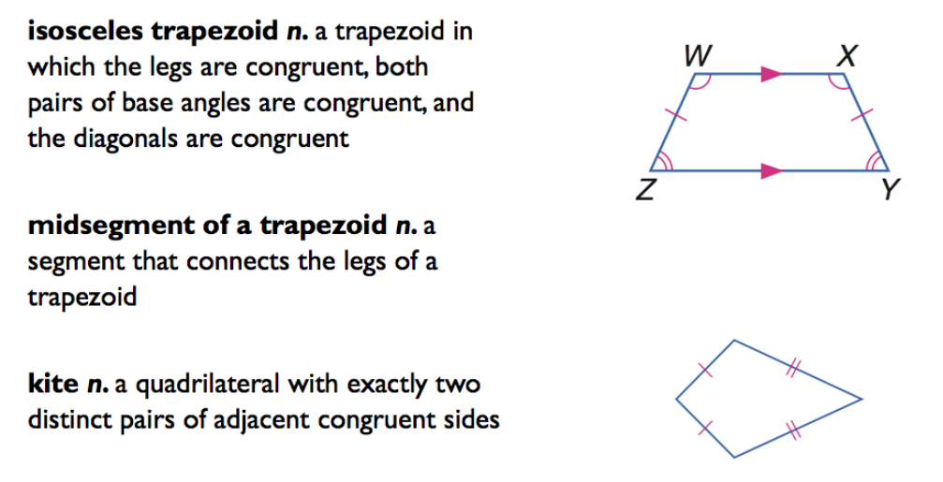

Isosceles Trapezoids

|  |  |
| --- | --- |
|  |  |
|  |  |
|  |  |

Proof:

Given: ABCD is an isosceles trapezoid (draw pic here pg 439)

Prove: AC is congruent to BD

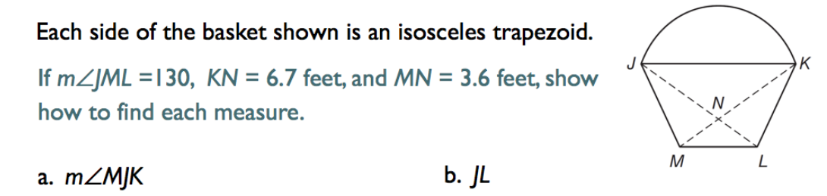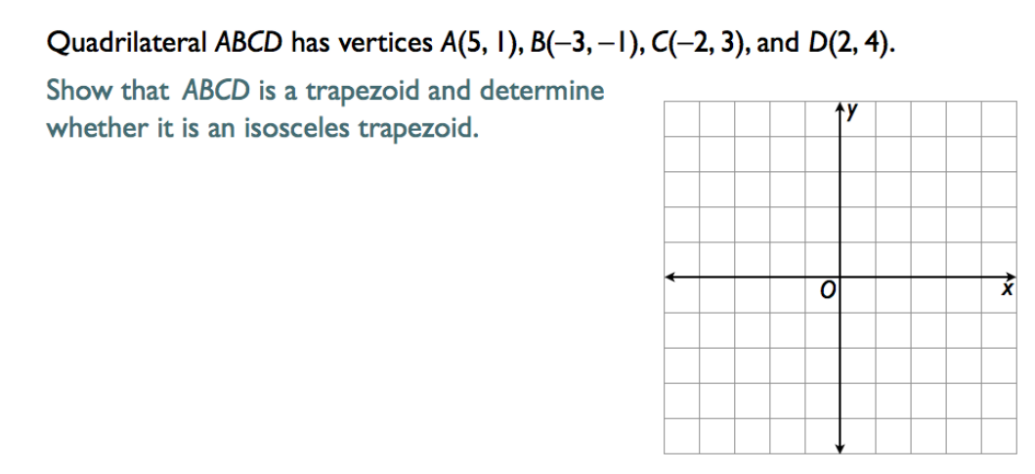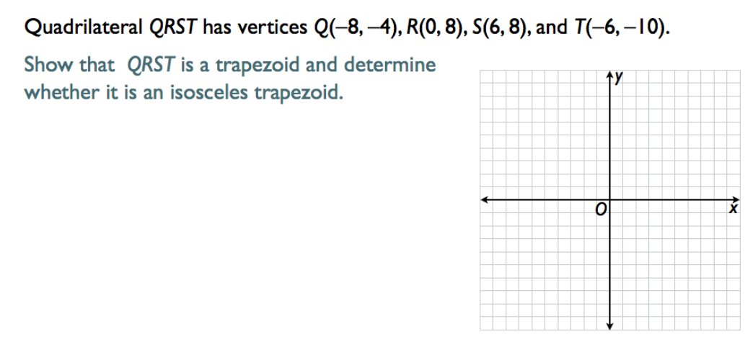

**Theorem: Trapezoid Midsegment Theorem** (copy box pg 441)

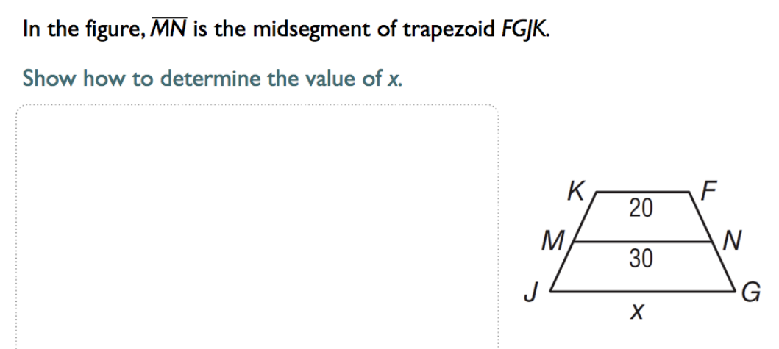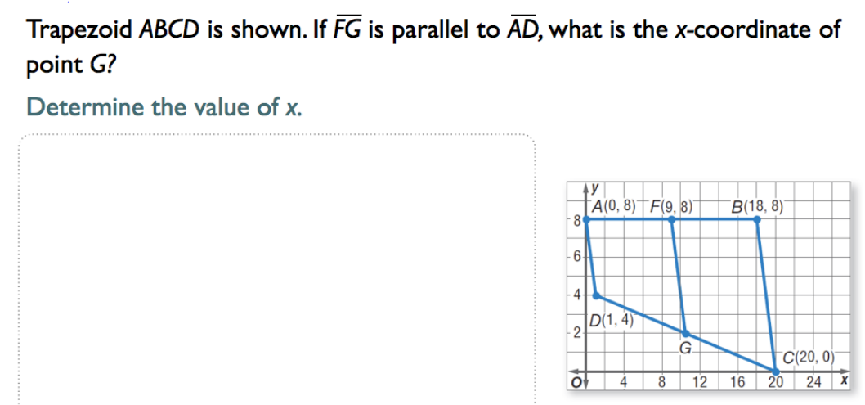

___________________________________________________________________

**Kites**

|  |  |
| --- | --- |
|  |  |
|  |  |

