Notes 6-4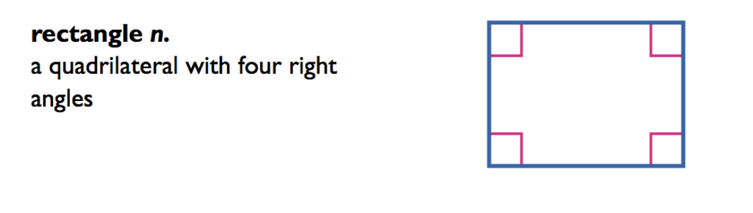

By definition, a rectangle has the following properties:
- All _______________________________________________________

- Opposite__________________________________________________

- Opposite __________________________________________________

- Consecutive _______________________________________________

- Diagonals _________________________________________________

- In addition, ________________________________________________

Theorem 6.13 Diagonals of a Rectangle
If a parallelogram is a __________________, then its __________________ are congruent.
Abbreviation ___________________________________________________
Example ______________________________________________________

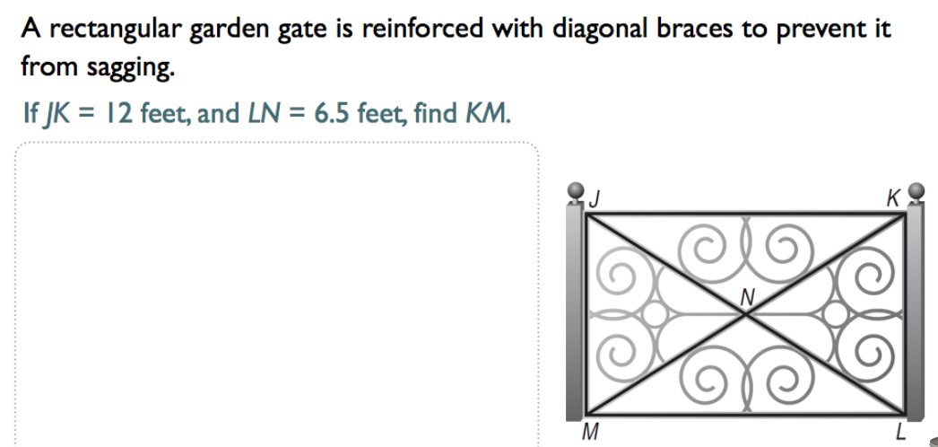

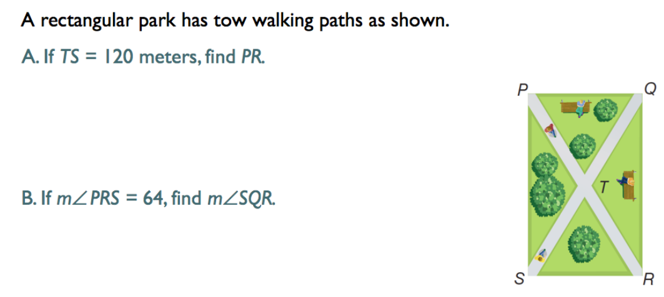

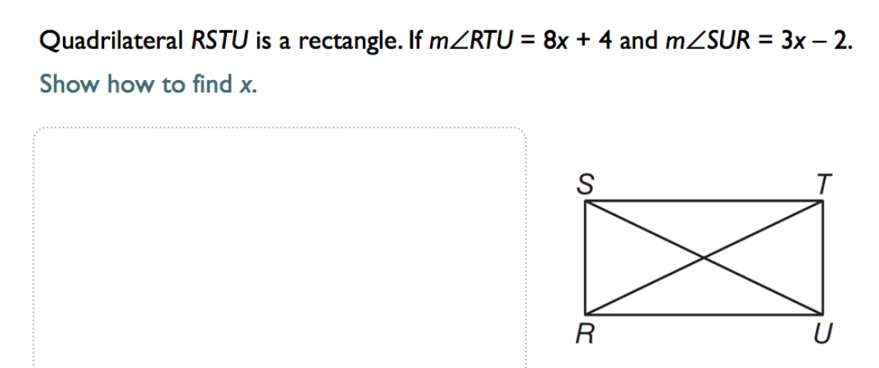

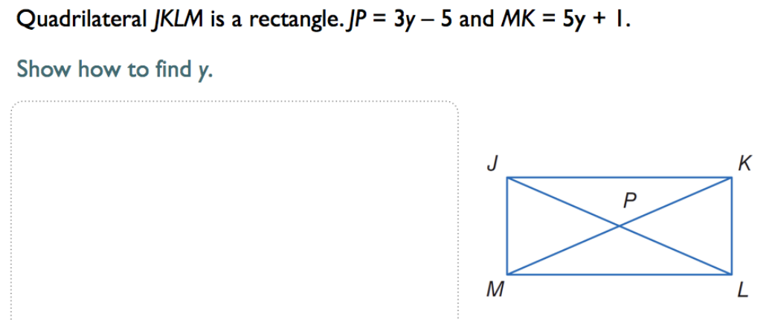

Theorem 6.14 Diagonals of a Rectangle
If the ___________________ of a parallelogram are congruent, then the Parallelogram is a __________________.
